

Setup Guide

Social Audience Manager
App Version 1.0
Doc Version 1.0
18 October 2011
Overview_________________________________

This document describes setting up any Indiatimes website to various Social Networking Websites

Feedback

Please direct any comments or suggestions about this document to:

Lalit Bansal <lalit.bansal@indiatimes.co.in>
Harsh Gupta <harsh.gupta@indiatimes.co.in>

Modifications and Updates

Version | Date | Description of Change
1.1 | 18 Oct 2011 | Written for Social Audience Manager v1.0
1.2 | 1 Nov 2011 | Added RSS feeds links & setup note for pages
Table of Contents

1) Login to Social Audience Manager: 4
2) Configure Indiatimes Website with facebook 5
3) Configure facebook pages with Indiatimes Website 8
Configuring Facebook Pages 9
1) Configuring manually created Facebook Pages 9
2) Configuring Open Graph created Facebook Pages 10
Feed links for TOI L1 Category Pages 11

1) Login to Social Audience Manager:

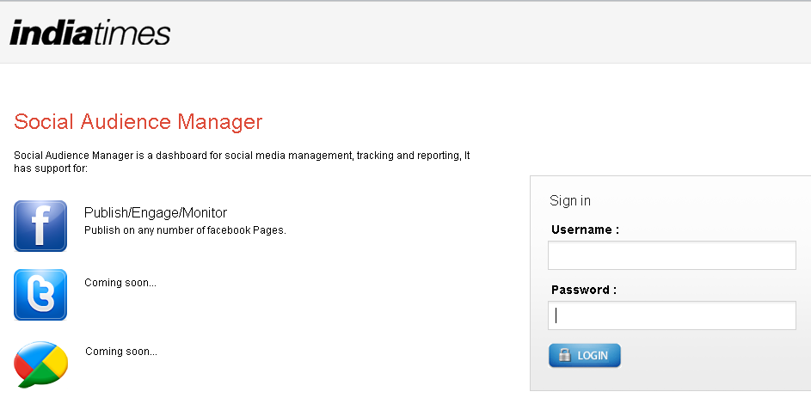
Login to http://audiencemanager.indiatimes.com via supplied credentials

2) Configure Indiatimes Website with facebook
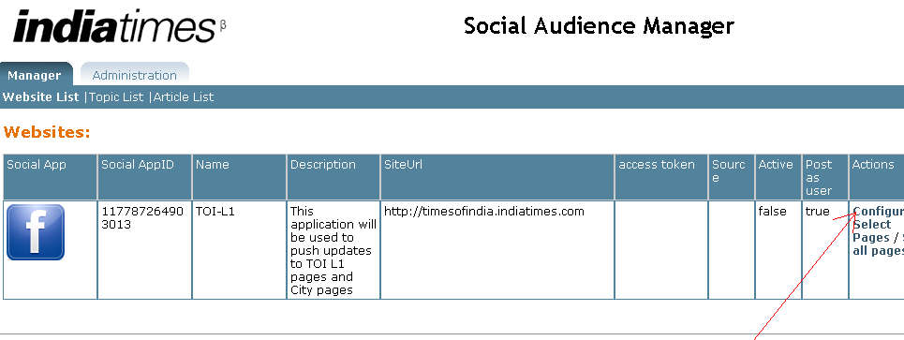

Click on configure link to generate access token. This will redirect to facebook login page, if you are not logged-in as below. If you are already login from the facebook account from which you want to select pages then move to next page.

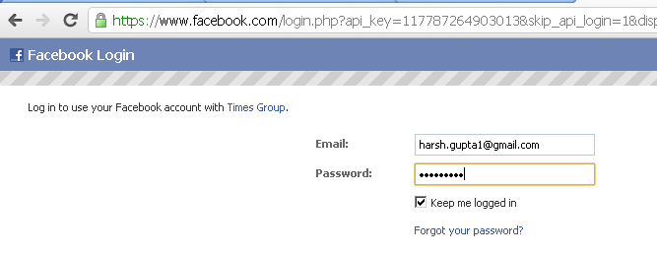

Enter your facebook credentials from which you want to select pages. After logging-in to facebook it will show “Request for Permission” screen dialog

Please ensure that at least below 7 permissions are visible before allowing the app.

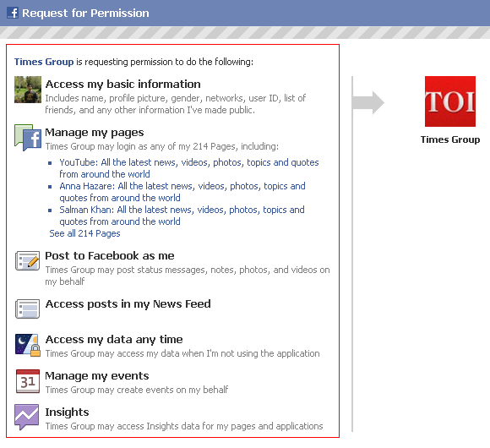

If these 7 permissions are not visible then delete the app as shown below and reconfigure the app
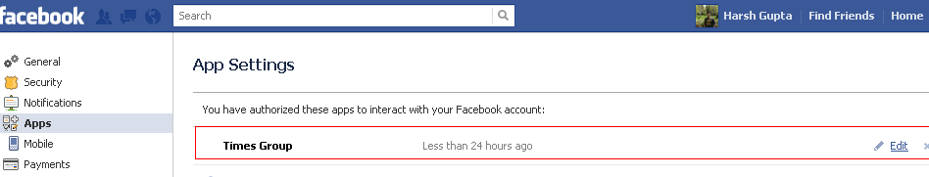
After allowing the facebook app, if everything is successful, then access token will be generated as shown below
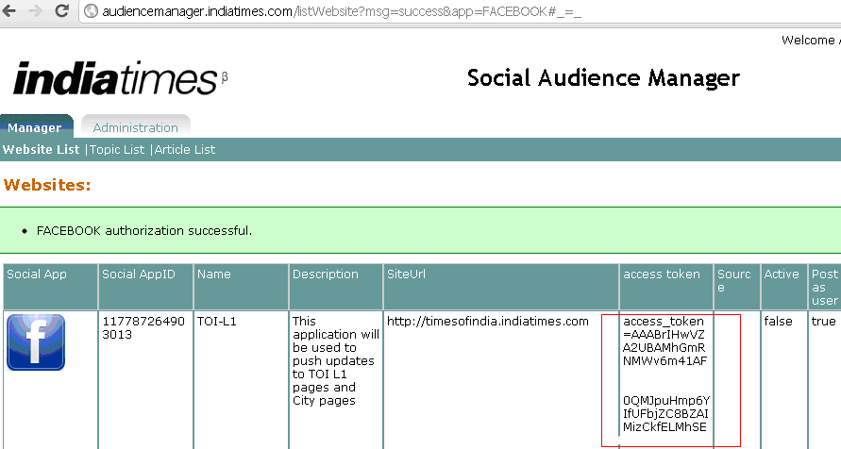

3) Configure facebook pages with Indiatimes Website

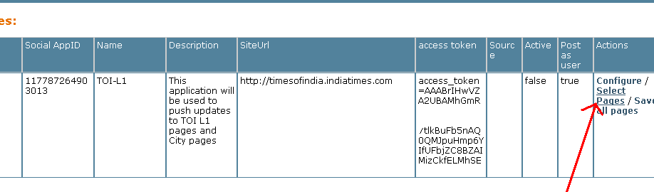
Clicking on “Select Pages” link will open the dialog as shown below. Select the facebook pages on which you want to push articles.

Configuring Facebook Pages

1) Configuring manually created Facebook Pages

- Click on “Edit” link to edit any topic

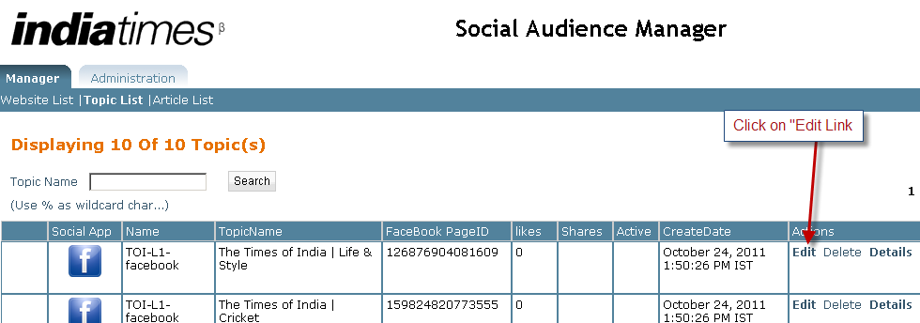

- Enter provided feed url, then click on “active” checkbox to enable feed pushing on corresponding facebook page.
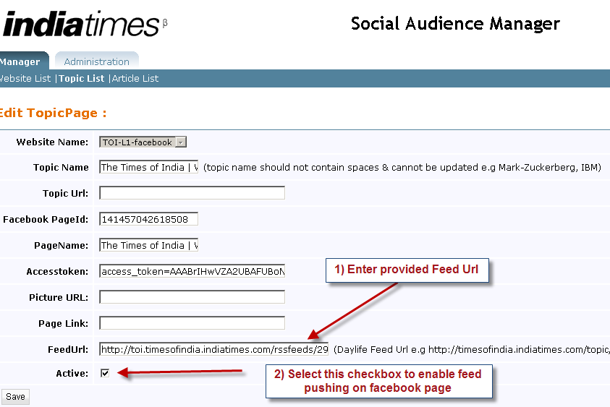

2) Configuring Open Graph created Facebook Pages
- Click on “Edit” link to edit any topic

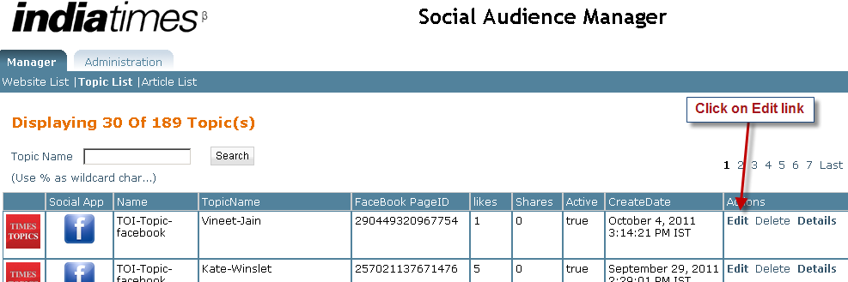

- Enter details as shown below
- 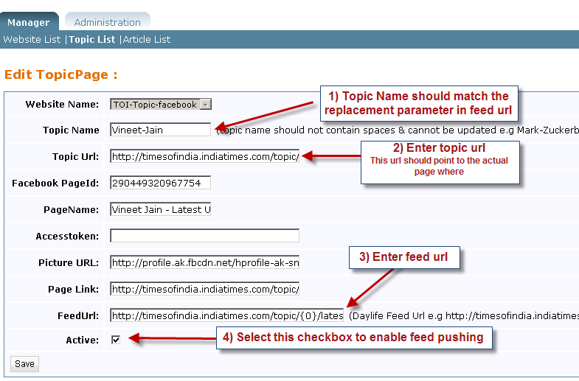

Feed links for TOI L1 Category Pages

S.No | Category | RSS Feed Link
1 | World | http://toi.timesofindia.indiatimes.com/rssfeeds/296589292.cms
2 | Business | http://toi.timesofindia.indiatimes.com/rssfeeds/1898055.cms
3 | Tech | http://toi.timesofindia.indiatimes.com/rssfeeds/5880659.cms
4 | Sports | http://toi.timesofindia.indiatimes.com/rssfeedsvideo/3813456.cms
5 | Cricket | http://toi.timesofindia.indiatimes.com/rssfeeds/4719161.cms
6 | Entertainment | http://toi.timesofindia.indiatimes.com/rssfeeds/1081479906.cms
7 | Movie Reviews | http://toi.timesofindia.indiatimes.com/rssfeeds/135762.cms
8 | Life & Style | http://toi.timesofindia.indiatimes.com/rssfeeds/2886704.cms
9 | Science | http://toi.timesofindia.indiatimes.com/rssfeeds/-2128672765.cms
10 | Environment | http://toi.timesofindia.indiatimes.com/rssfeeds/2647163.cms
11 | NRI | http://toi.timesofindia.indiatimes.com/rssfeeds/7098551.cms
12 | Blogs | http://blogs.timesofindia.indiatimes.com/main/feed/entries/rss
13 | Cities->Mumbai | http://toi.timesofindia.indiatimes.com/rssfeeds/-2128838597.cms
14 | Cities->Delhi | http://toi.timesofindia.indiatimes.com/rssfeeds/-2128839596.cms
15 | Cities-> Bangalore | http://toi.timesofindia.indiatimes.com/rssfeeds/-2128833038.cms
16 | Cities-> Hyderabad | http://toi.timesofindia.indiatimes.com/rssfeeds/-2128816011.cms
17 | Cities-> Chennai | http://toi.timesofindia.indiatimes.com/rssfeeds/2950623.cms
18 | Cities-> Ahemdabad | http://toi.timesofindia.indiatimes.com/rssfeeds/-2128821153.cms
19 | Cities-> Allahabad | http://toi.timesofindia.indiatimes.com/rssfeeds/3947060.cms
20 | Cities-> Bhubaneswar | http://toi.timesofindia.indiatimes.com/rssfeeds/4118235.cms
21 | Cities-> Chandigarh | http://toi.timesofindia.indiatimes.com/rssfeeds/-2128816762.cms
22 | Cities-> Coimbatore | http://toi.timesofindia.indiatimes.com/rssfeeds/7503091.cms
23 | Cities-> Goa | http://toi.timesofindia.indiatimes.com/rssfeeds/3012535.cms
24 | Cities-> Gurgaon | http://toi.timesofindia.indiatimes.com/rssfeeds/6547154.cms
25 | Cities-> Guwahati | http://toi.timesofindia.indiatimes.com/rssfeeds/4118215.cms
26 | Cities-> Hubli | http://toi.timesofindia.indiatimes.com/rssfeeds/3942695.cms
27 | Cities-> Indore New | http://toi.timesofindia.indiatimes.com/rssfeeds/9644624.cms
28 | Cities-> Jaipur | http://toi.timesofindia.indiatimes.com/rssfeeds/3012544.cms
29 | Cities-> Kanpur | http://toi.timesofindia.indiatimes.com/rssfeeds/3947067.cms
30 | Cities-> Kolkata | http://toi.timesofindia.indiatimes.com/rssfeeds/-2128830821.cms
31 | Cities-> Kochi New | http://toi.timesofindia.indiatimes.com/rssfeeds/9710057.cms
32 | Cities-> Kozhikode New | http://toi.timesofindia.indiatimes.com/rssfeeds/9710567.cms
33 | Cities-> Lucknow | http://toi.timesofindia.indiatimes.com/rssfeeds/-2128819658.cms
34 | Cities-> Ludhiana | http://toi.timesofindia.indiatimes.com/rssfeeds/3947051.cms
35 | Cities-> Madurai New | http://toi.timesofindia.indiatimes.com/rssfeeds/9632514.cms
36 | Cities-> Mangalore | http://toi.timesofindia.indiatimes.com/rssfeeds/3942690.cms
37 | Cities-> Mysore | http://toi.timesofindia.indiatimes.com/rssfeeds/3942693.cms
38 | Cities-> Nagpur | http://toi.timesofindia.indiatimes.com/rssfeeds/442002.cms
39 | Cities-> Noida | http://toi.timesofindia.indiatimes.com/rssfeeds/8021716.cms
40 | Cities-> Patna | http://toi.timesofindia.indiatimes.com/rssfeeds/-2128817995.cms
41 | Cities-> Pune | http://toi.timesofindia.indiatimes.com/rssfeeds/-2128821991.cms
42 | Cities-> Rajkot | http://toi.timesofindia.indiatimes.com/rssfeeds/3942663.cms
43 | Cities-> Ranchi | http://toi.timesofindia.indiatimes.com/rssfeeds/4118245.cms
44 | Cities-> Thane | http://toi.timesofindia.indiatimes.com/rssfeeds/3831863.cms
45 | Cities-> Surat | http://toi.timesofindia.indiatimes.com/rssfeeds/3942660.cms
46 | Cities-> Thiruvananthapuram | http://toi.timesofindia.indiatimes.com/rssfeeds/878156304.cms
47 | Cities-> Vadodara | http://toi.timesofindia.indiatimes.com/rssfeeds/3942666.cms
48 | Cities-> Varanasi | http://toi.timesofindia.indiatimes.com/rssfeeds/3947071.cms

